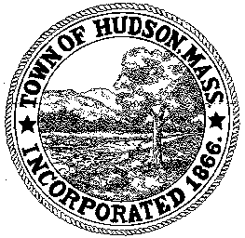

CONSERVATION COMMISSION
78 Main Street, Hudson, MA 01749
(978) 568-2020

Paul Byrne, Chairman W. Minot Wood, Vice Chairman David Esteves, Member

Terrence Joyce, Member Leif Longtine, Member Joseph Rodrigues, Member Al Tashian, Member

Agenda
January 7, 2010 7:00 P.M.

- Preliminaries
  - Open Meeting
  - Roll Call
1.3 Additions or Deletions to the agenda

2.0 Hearings and Appointments
2.1 Enforcement Order - Continued
7 Freeman Circle
2.2 Certificate of Compliance
6 Lakeside Avenue
2.3 Conservation Restriction
2.4 Benderson Development – Update on Highland Commons

3.0 General Business
3.1 Questions and Comments from the Public
3.2 Request to attend MACOLAP 23rd Annual Winter Workshop

4.0 Adjournment

Next Meeting January 21, 2010

